EE 115C Digital Electronic Circuits

Winter 2003

Midterm Examination

Closed Book

One Sheet of Notes Allowed

Name: _______________________________

Student ID No.:_________________________

- ________ / 10

- ________ / 10

- ________ / 10

- ________ / 10

- ________ / 10

TOTAL _________ / 50
Problem 1.
10 pts

Given the set of measurements shown in the table below for a single transistor, determine the following parameters:
λ, V_{T0,} 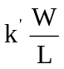, V_{DSAT}

V_{GS}(V) | V_{DS}(V) | V_{SB}(V) | I_{D}(μA) | Initial guess for V_{min}
2.0 | 2.0 | 0 | 1160
2.0 | 2.5 | 0 | 1200
2.5 | 2.5 | 0 | 1800
1.2 | 0.8 | 0 | 260.68
1.0 | 0.8 | 0 | 133
0.7 | 0.8 | 1.0 | 0.008512

Hint:
1. First make a guess as to the value of V_{min}. Since you are not given V_{DSAT}, you need to make an engineering guess as to what V_{min} is for each measurement and then validate your guess
2. Calculate the parameters in the following order: λ, V_{T0}, V_{DSAT}, 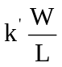

Problem 2.
10 pts
Compute the gate capacitance (Cg) and drain diffusion capacitance (Cd) for the transistor shown below. Calculate these capacitances for the three cases when
i) Vout = 0V,
ii) Vout = 0.5V and
iii) Vout = 2.5V.
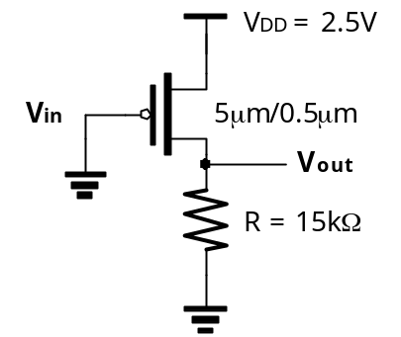

Assume that the drain area is rectangular and 5μm wide on either side. Use the following parameters to determine the capacitance values. For PMOS, VT0 = -0.4V and VDSAT = -1V.
C_{OX} = 6f F/μm² | C₀ = 0.27f F/μm
C_{j0} = 1.9f F/μm² | m_{j} = 0.5
Ф_{b} = 0.9 V | C_{jsw0} = 0.22f F/μm
m_{jsw} = 0.5 | Ф_{bsw} = 0.9 V

Problem 3.
Given the following circuit:
10 pts
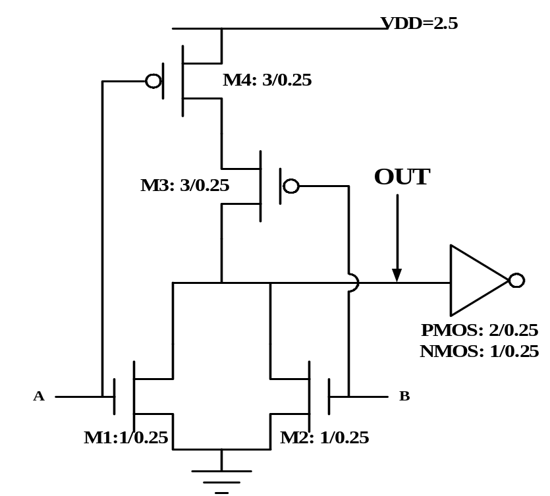

3a) What is the logic function implemented by the circuit? Verify your answer with the following table. For each row give the state of each transistor in steady state, and the voltage and node OUT. Write your answers in the table.
5 pts

A | B | M1 | M2 | M3 | M4 | OUT (V)
0 | 0
0 | 1
1 | 0
1 | 1

3b) What is the total capacitance at the output node OUT?
5 pts
Assume that the Diffusion capacitances for all the transistors are equal to 1fF irrespective of the size of the transistor, and Cox = 6fF/μm². Ignore the wiring and gate overlapping capacitance.

Problem 4.

Extract the circuit for the layout shown below.
Hint: Label all nodes on the layout and then start tracing the layout from the two inputs to the output.

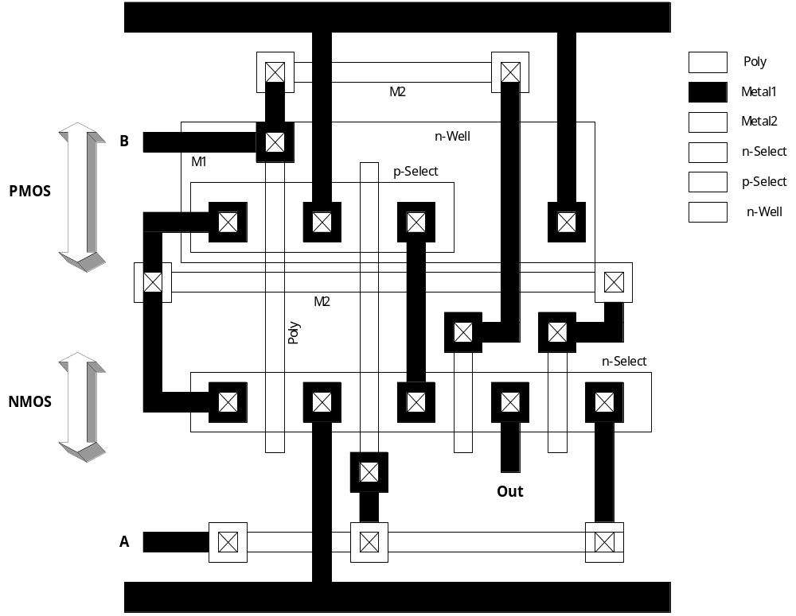

Problem 5. Short Answer
10 pts
5a) Write the spice command lines needed to generate a Voltage Transfer Curve (VTC) using DC analysis for an NMOS transistor circuit below. Assume the technology file is given and the file name is 0.25micron.txt where the model name of NMOS is ‘nm’. Let the step size of DC analysis to be 0.1V
5 pts

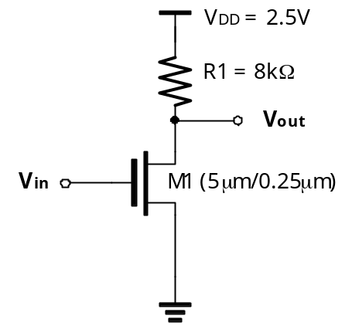

3 pts
5b) Put the following semiconductor fabrication processing steps in the proper order starting with the one that occurs first in the fabrication process.
- Metal deposition
- N-Well creation
- Source Drain Diffusion
- PolySilicon depositions

5c) How is the threshold voltage of a gate defined?
2 pts

